10.3.10 Render - Cycles Render Engine - Render Baking
Open Shading Language 1
Options 1
Bake Mode 1
Additional Options 3

Open Shading Language

Render Baking
Refer to the Blender Render page for general baking guidelines
Cycles uses the render settings (samples, bounces, …) for baking. This way the quality of the baked textures should match the result you get from the rendered scene.
The baking happens into the respective active textures of the object materials. The active texture is the last selected Image Texture node of the material node tree. That means the active object (or the selected objects, when not baking ‘Selected to Active’) needs a material, and that material needs at least an Image Texture node, with the image to be used for the baking. Note, the node does not need to be connected to any other node. The active texture is what projection painting and the viewport use as a criteria to which image to use. This way after the baking is done you can automatically preview the baked result in the Texture mode.

Options
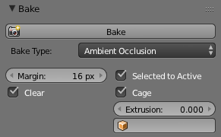
Ambient Occlusion Pass.

Bake Mode
Combined
Bakes all materials, textures, and lighting except specularity.
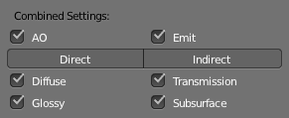
Combined Pass Options.
The passes that contribute to the combined pass can be toggled individually to form the final map.
Ambient Occlusion
Bakes ambient occlusion as specified in the World panels. Ignores all lights in the scene.
Shadow
Bakes shadows and lighting.
Normals
Bakes normals to an RGB image.
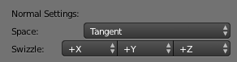
Normal Pass Options.
Normal Space
Normals can be baked in different spaces:
Object space
Normals in object coordinates, independent of object transformation, but dependent on deformation.
Tangent space
Normals in tangent space coordinates, independent of object transformation and deformation. This is the default, and the right choice in most cases, since then the normal map can be used for animated objects too.
Normal Swizzle
Axis to bake into the red, green and blue channel.
For materials the same spaces can be chosen in the image texture options next to the existing Normal Map setting. For correct results, the setting here should match the setting used for baking.
UV
Bakes colors of materials and textures only, without shading.
Emit
Bakes Emission, or the Glow color of a material.
Environment
Bakes the environment as seen from the center of the object.
Diffuse, Glossy, Transmission, Subsurface
Bakes the diffuse, glossiness, transmission of subsurface pass of a material.
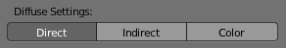
Diffuse Pass Options.
- If only color is selected you get the pass color, which is a property of the surface and independent of sampling refinement.
- If color is not selected, you get the direct and/or indirect contributions in grayscale.
- If color and either direct or indirect are selected, you get the direct and/or indirect contributions colored.

Additional Options
Margin
Baked result is extended this many pixels beyond the border of each UV “island,” to soften seams in the texture.
Clear
If selected, clears the image before baking render.
Select to Active
Bake shading on the surface of selected objects to the active object. The rays are cast from the lowpoly object inwards towards the highpoly object. If the highpoly object is not entirely involved by the lowpoly object, you can tweak the rays start point with Ray Distance or Cage Extrusion (depending on whether or not you are using cage). For even more control you can use a Cage Object.
Note
Memory Usage
There is a CPU fixed memory footprint for every object used to bake from. In order to avoid crashes due to lack of memory, the highpoly objects can be joined before the baking process. The render tiles parameter also influence the memory usage, so the bigger the tile the less overhead you have, but the more memory it will take during baking (either in GPU or CPU).

Cage
Cast rays to active object from a cage. A cage is a ballooned-out version of the lowpoly mesh created either automatically (by adjusting the ray distance) or manually (by specifying an object to use). When not using a cage the rays will conform to the mesh normals. This produces glitches on the edges, but it is a preferable method when baking into planes to avoid the need of adding extra loops around the edges.
Ray Distance
Distance to use for the inward ray cast when using selected to active. Ray distance is only available when not using Cage.
Cage Extrusion
Distance to use for the inward ray cast when using Selected to Active and Cage. The inward rays are casted from a version of the active object with disabled Edge Split Modifiers. Hard splits (e.g., when the Edge Split Modifier is applied) should be avoided because they will lead to non-smooth normals around the edges.
Cage
Object to use as cage instead of calculating the cage from the active object with the Cage Extrusion.
Note
When the base mesh extruded does not give good results, you can create a copy of the base mesh and modify it to use as a Cage. Both meshes need to have the same topology (number of faces and face order).

